**Name: Ali Ather**

**Roll No: 47-BSCS-20**

**Section: CSA2**

**Question No: 1**

**Program:**

import pandas

from sklearn.ensemble import RandomForestClassifier

import matplotlib.pyplot as plt

from sklearn.tree import plot_tree

df = pandas.read_csv("sample.csv")

features = ['sepal_length','sepal_width','petal_length','petal_width']

X = df[features]

y = df['species']

rf = RandomForestClassifier()

rf = rf.fit(X, y)

for i in range(3):

    fig = plt.figure(figsize=(20,15))

    plot_tree(rf.estimators_[0],

              feature_names=X.columns,

              filled=True, impurity=True,

              rounded=True)

    fig.savefig(f"tree{i}")

**Output:**

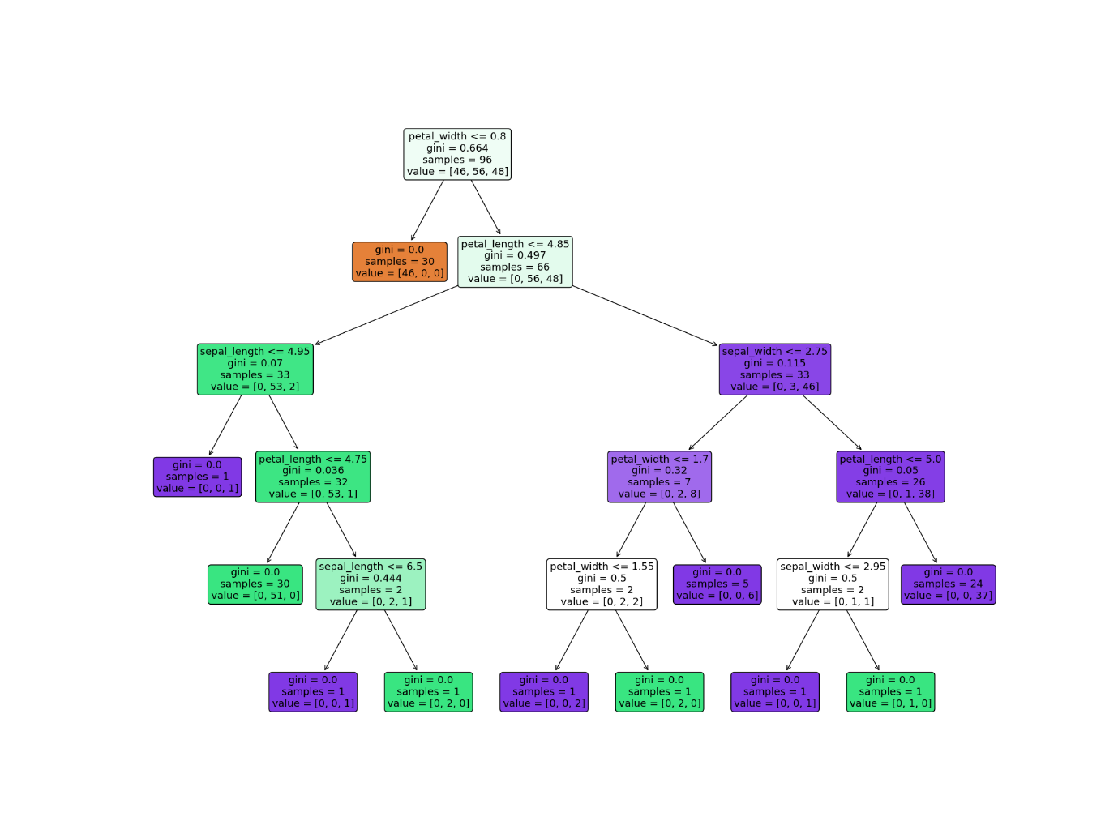

**Question No: 2**

**(part A)**

**Program:**

import nltk

from nltk.corpus import stopwords

passage= 'Atoms of radioactive elements can split. According to Albert Einstein, mass and energy are interchangeable under certain circumstances. When atoms split, the process is called nuclear fission.'

# to convert into tokens

tokenize= nltk.word_tokenize(passage)

stop_word= set(stopwords.words('english'))

filter=[]

# loop to check stopwords

for word in tokenize:

    if word not in stop_word:

        filter.append(word)

print(filter)

**Output:**

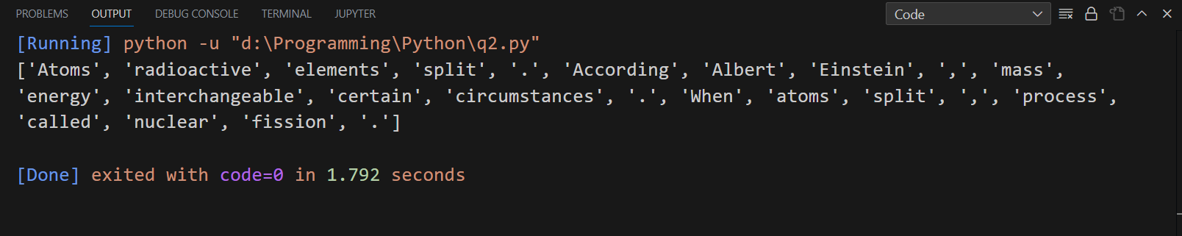

**Question No: 2**

**(part B)**

**Program:**

# program to find factorial of the given number

def factorial(n):

    result=1

    if n>0:

        while n>0:

            result= result*n

            n=n-1

        print("factorial: ",result)

    else:

        print('Number is not valid')

number= int(input("Enter any Number: "))

# print(number)

factorial(number)

**Output:**

